附件 2：嘉宾简介（按演讲顺序排列）

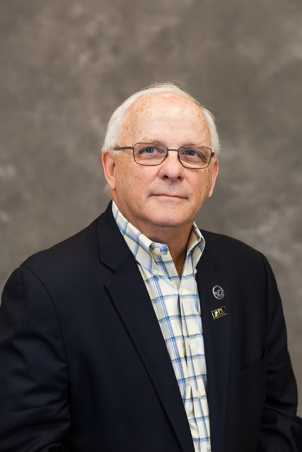  美国毒理科学院院士（Fellow ATS）  美国毒理科学院前院长  美国毒理资格认证理事会（ABT）  前理事长 | William J Brock, PhD. With over 30 years of experience, he provides scientific and regulatory consulting advice and safety and risk assessments to clients in the pharmaceutical, chemical, medical device, food, and consumer product industries. Dr. Brock has authored or co-authored more than 50 publications, and has authored or co-authored several book chapters and is a co-editor on two toxicology and regulatory books. He has served as a member for several toxicology organizations including US National Research Council, the US National Toxicology Program, International Pharmaceutical Excipients Council, American Association of Pharmaceutical Scientists, the Chinese government, and others. Dr. Brock is currently an expert reviewer for IPEC’s Excipients Panel and serves on several toxicology national committees. Dr. Brock is a Diplomate of the American Board of Toxicology and a Fellow of the Academy of Toxicological Sciences, and has served as a board member and president for both ABT and ATS. Dr. Brock has served in various leadership roles or as a member for the American College of Toxicology, Society of Toxicology, Roundtable of Toxicology Consultants, and the Drug Information Association. Dr. Brock is a reviewer and editorial board member for several leading toxicology journals.
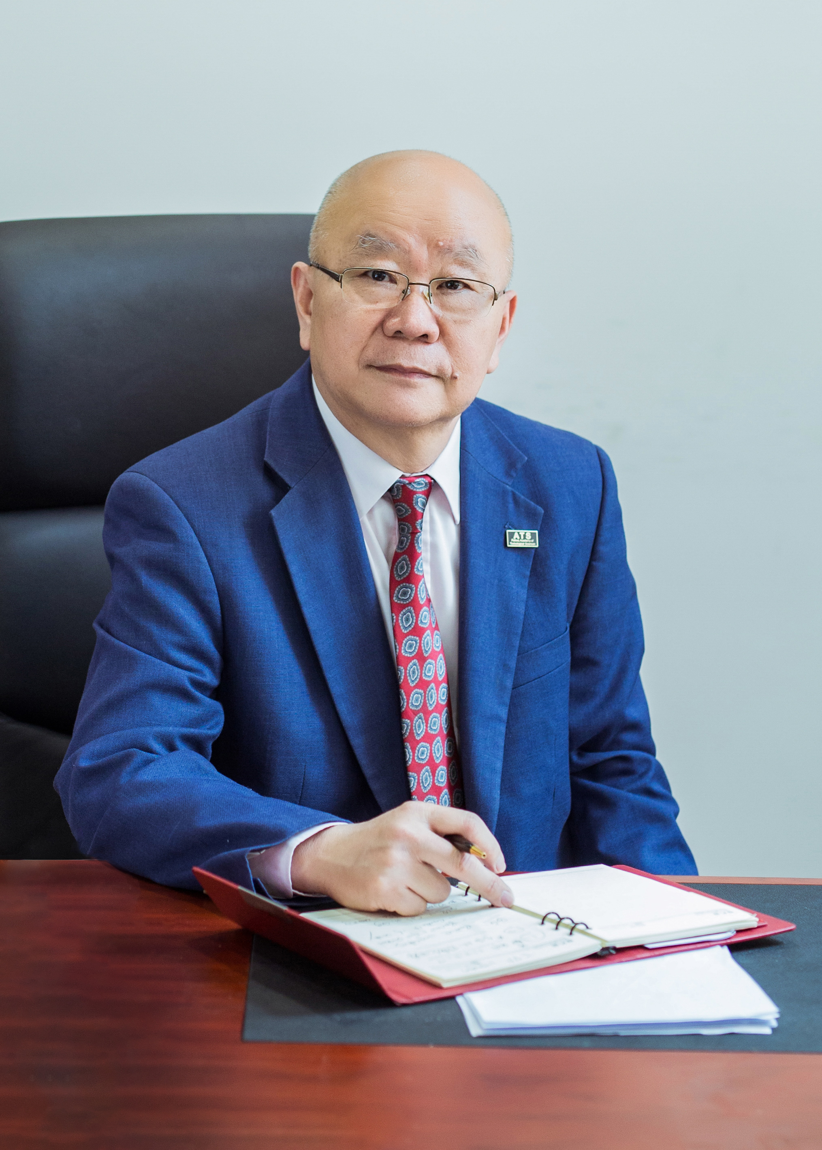  美国毒理科学院院士（Fellow ATS）  中国毒理学会常务理事、前任副  理事长兼秘书长  亚洲毒理学会主席  国际毒理学联合会执委、继续教育  委员会主席 | 付立杰，博士，美国毒理科学院院士（Fellow, ATS），上海益诺思生物技术股份有限公司(国家上海新药安全评价研究中心)副总裁。中国毒理学会前任副理事长兼秘书长，亚洲毒理学会现任主席(2018-2021)，国际毒理学联合会（IUTOX）执委、并兼任其继续教育委员会共同主席和毒理学资格国际互认委员会主席。1987年在原上海医科大学获得博士学位，是我国第一位毒理学研究方向的医学博士;2011年入选美国毒理科学院院士，2014年获得美国杰出华人毒理学家奖，2018年获得美国毒理学院“无名英雄奖”。现任国际毒理学杂志（Intl J of Toxicology）编委，国际免疫毒理学杂志编委，中国药理学与毒理学杂志编委会顾问。付博士先后主编出版了《现代毒理学及其应用》《畸胎学》《现代毒理学简明教程》《The Study Director in Nonclinical Studies for Drugs, Chemicals, Pesticides & Devices》《现代毒理学》等学术专著，并先后发表过上百篇论文和文章。
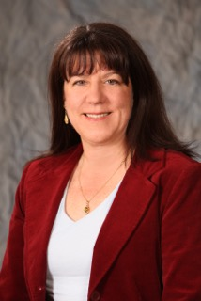  美国毒理科学院院士（Fellow ATS）  美国毒理学院前任主席  国际毒理学联合会执委、财务总管 | Mary Ellen Cosenza, PhD, DABT, ATS, RAC, is a regulatory consultant with over 35 years of senior leadership experience in the biopharmaceutical industry in the US, Europe, and emerging markets. During her 20-year tenure at Amgen, she led the US Regulatory Department and the International Emerging Markets Regulatory Department and served as an executive director of global regulatory affairs and safety, focusing on early development and inflammation. In addition to her leadership roles in regulatory affairs, she also served as the senior director of toxicology at Amgen. Mary Ellen was a member of an Expert Working Group, operating under the auspices of the International Conference on Harmonization (ICH), for ICH M3(R2). Mary Ellen is well published in the field of biological drug development and has authored several chapters on this topic as well. Mary Ellen is a Diplomate of the American Board of Toxicology, a Fellow of the Academy of Toxicological Sciences, and a member of the Society of Toxicology (SOT), Drug Information Association (DIA), and Regulatory Affairs Professional Society (RAPS). She also holds a Regulatory Affairs Certification for both the US and EU. Mary Ellen received her PhD from St. John’s University, New York, and her MS in regulatory science from the University of Southern California, Los Angeles.
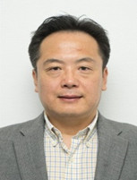  美国认证毒理学家（DABT）  罗氏上海研发中心药物科学部负责人 | Jack Xie , PhD, DABT. The Site Head of Pharmaceutical Sciences in Roche Innovation Center Shanghai and taking executive responsibilities of multi functions including toxicology, DMPK, investigative safety, Bioanalysis, Biomarker, and clinical pharmacology. He is also Roche China Animal Welfare Officer. He is a member of Roche China Leadership team and a member of Roche Global Non-clinical Drug Safety Committee, which is a governance body to review and endorse all EIH programs in different therapeutic areas. Jack received his PhD in Pharmacology and Toxicology from University in Rhode Island (USA), MS in pharmacology and BS in Pharmacy form Peking University. He is a certified toxicologist by the American Board of Toxicology (DABT) and the full member of Society of Toxicology (SOT). He is also a council member of Chinese Society of Toxicology (CSOT). Jack used to serve as a regulatory toxicologist for more than 6 years in Targacept, Inc, a bio-pharmaceutical company in Winston Salem, North Carolina. Before Targacept, Jack worked as a study director of toxicology at Toxickon Corp., a non-clinical CRO at Bedford, Massachusetts (USA).

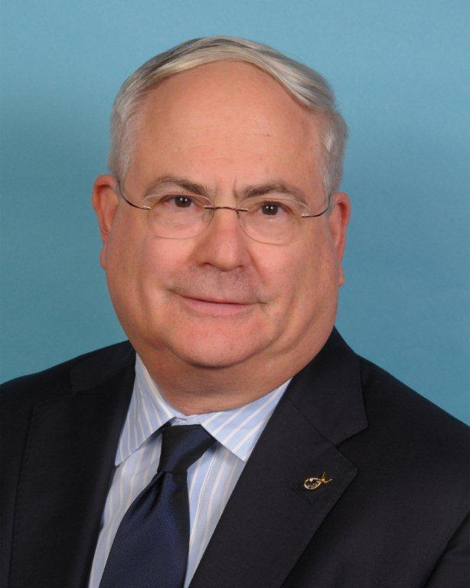  美国毒理科学院院士（Fellow ATS）  美国畸胎学会前任主席、国际畸胎  学会联盟前任主席  美国毒理学会生殖与发育毒理专业  委员会主席 | Alan Hoberman Ph.D., has been employed by Charles River Laboratories, Preclinical Services, Pennsylvania (formerly Argus Research Laboratories, Inc.) Prior to joining Argus Research, Dr. Hoberman was the Head of Reproductive Toxicology at Hazleton Laboratories in Vienna, Virginia. He was a graduate student in Anatomy at the University of Virginia before moving to Arkansas and completing a MS in Interdisciplinary Toxicology from the University of Arkansas and a Ph.D. in Toxicology from Pacific Western University. He is a Diplomat of the American Board of Toxicology and a Fellow of the Academy of Toxicological Sciences, with over 85 publications and book chapters. He is the co-editor of “Pediatric Non-Clinical Drug Testing, Principles, Requirements, and Practices” published in January 2012.Dr. Hoberman has been a member of the American College of Toxicology since 1979 and is currently the Treasurer and serves on the Editorial Board of the ACT Journal, International Journal of Toxicology. He is Past President of the Reproductive and Developmental Toxicity Specialty Section of the Society of Toxicology and Past President of the Middle Atlantic Reproductive and Teratology Association, as well as Past President of the Arkansas Biotechnology Organization.
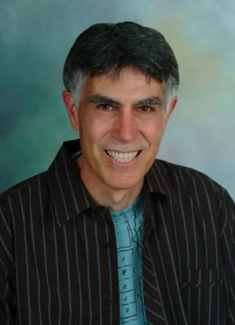  美国认证毒理学家（DABT）  美国制药协会药品安全委员会  前任主席  国际毒理学杂志前主编 | John C. Kapeghian, Ph.D., D.A.B.T., is an independent consultant (Preclinical Safety Associates, LLC; Reno, NV, USA) specializing in toxicology and drug safety. John also assists contract laboratories in study management, report review and regulatory advisory services. He was formerly head of Charles River’s Navigator Scientific and Regulatory Consulting group, and held senior management positions at Sierra Biomedical, a contract laboratory subsequently acquired by Charles River. Dr. Kapeghian previously worked for Ciba Pharmaceuticals (now Novartis), heading up regulatory toxicology units and directing their U.S. Experimental Toxicology program. He received his Ph.D. in pharmacology/toxicology from the University of Mississippi (Oxford campus) and has been board-certified in general toxicology by the American Board of Toxicology since 1985. John is a member of the American College of Toxicology (ACT), and Society of Toxicology (SOT). He formerly chaired the Pharmaceuticals Manufacturing Association’s DRUSAFE committee on In Vitro Toxicology and also served as a Section Editor for the International Journal of Toxicology from 1988 - 2008. John has experience in small molecule, peptide/protein, antisense oligonucleotide, and biologics development, as well as in expert review of medical device safety.

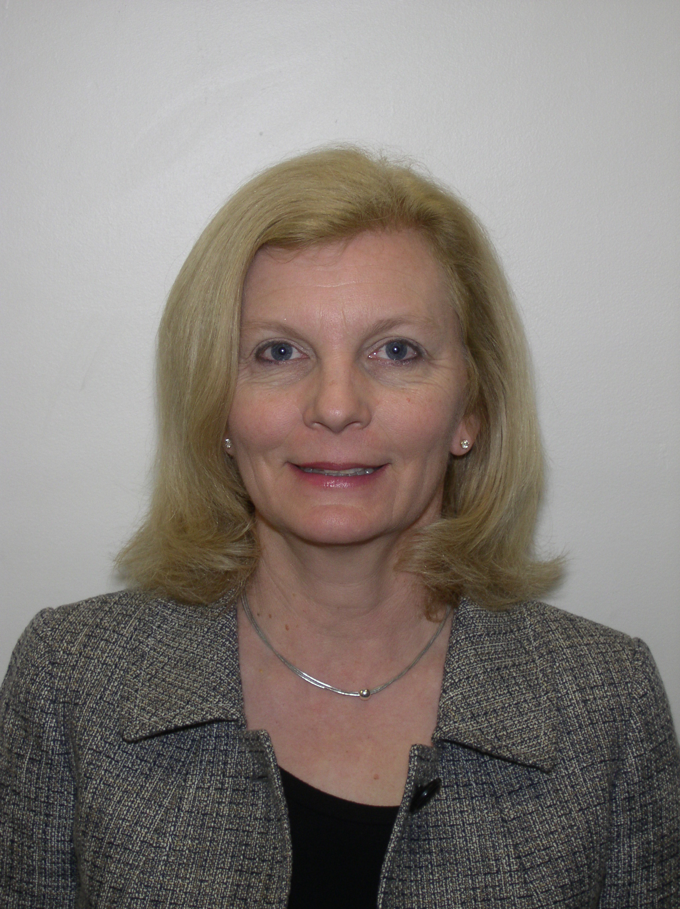  美国认证毒理学家（DABT）  大西洋（中部）毒理学会常务理事  美国工业健康理事会致突变专委会  委员 | Lydia Cox, Ph.D., DABT. Lydia is the Director of Regulatory Affairs at Nichino America, Inc., a wholly owned subsidiary of Nihon Nohyaku Co. Ltd., Tokyo, Japan. In her current role, she leads the regulatory affairs team and is focused on the development, registration, and stewardship of products for the crop protection sector in the US, Canada, and Mexico. She has a Ph.D. in toxicology from University of the Sciences. After completing her post-doctoral training at New York University’s Institute of Environmental Medicine, Lydia joined DuPont’s Haskell Global Centers for Health and Environmental Sciences. She has served as a Council Member for the Mid-Atlantic Society of Toxicology and a member of the Mutagenicity Subcommittee of the American Industrial Health Council. She has lectured at the University of Delaware on environmental, genetic and molecular toxicology and on pesticide toxicology for the Advanced Comprehensive Toxicology course offered by the ACT. She has been an ad hoc reviewer for Fundamental and Applied Toxicology, Toxicology In Vitro, and Drug and Chemical Toxicology. She is the author or co-author of 7 publications, 3 book chapters, and numerous abstracts. Lydia has also worked as a toxicology consultant for Critical Path Services for projects in the industrial chemical, medical device, and cosmetic sectors. She is a Diplomate of the American Board of Toxicology.
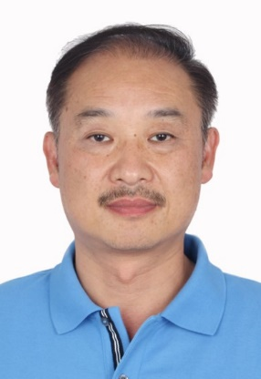  美国认证毒理学家（DABT）  北京康辰药业股份有限公司研究中心总经理 | Huaizhong Hu, MD, Ph.D,DABT, serves currently as the general manager of the research institute at Beijing Konruns Pharmaceutical Company. Prior to Konruns Dr. Hu spent 10 years at Covance Laboratory and held senior scientific positions as Toxicology Senior Study Director, Immunotoxicology Lead Scientist at Covance U.S. and most recently Early Development Scientific Director at Covance Shanghai. Dr. Hu was a Lee Kuan Yew Research Fellow and Principal Investigator at the Department of Microbiology, Faculty of Medicine at National University of Singapore. He received his Medical Degree from West China University of Medical Sciences and subsequently practiced for 3 years in Clinical Immunology at Huaxi University Hospital. He was a Postdoctoral Fellow in immunology and toxicology at the NIH where he successfully cloned and functionally evaluated a recombinant immunotoxin that has been developed and tested in a Phase II clinical trial for skin T cell lymphoma. He has authored over 60 publications in peer-reviewed international biomedical journals, and is an inventor of over 20 U.S., Europe and China issued or pending patents.

